REPORT ABOUT COUPLING AND COHESION LEVEL

**CONTROLLER**

package controller;  
import entity.cart.Cart;  
import entity.cart.CartMedia;  
import entity.media.Media;  
import java.util.List;  
public class BaseController {  
 public BaseController() {  
 }  
 public CartMedia checkMediaInCart(Media media) {  
 return Cart.*getCart*().checkMediaInCart(media);  
 }  
  
 public List getListCartMedia() {  
 return Cart.*getCart*().getListMedia();  
 }  
}

* Logical cohesion
* Stamp coupling

This class has a very low level of cohesion as it does not have any attributes or methods that show its’ functionalities. In fact, it only has two methods that return the result from other classes in other packages.

Solution: This class needs to be removed. The two methods inside this class will need to be placed elsewhere that is more relevant to their functionalities.

Other classes in this “Controller” package have procedural cohesion and stamp coupling. This is because the “Controller” classes have the main function of controlling the flow of actions when performing a specific use case (Procedural cohesion) and it requires information passed from other classes.

**UTILS**

The two classes in the “Utils” package have very low level of cohesion (Coincidental cohesion) and very high level of coupling as it is created as a collection of methods and paths used regularly by other classes, which does not relate to each other. So even though it is at a not-desirable level of cohesion and coupling, it does not need to be changed. Also, there are not many methods in this project, so this package does not need further refactoring.

**ENTITY**

In this package, all classes have high level of cohesion. The classes serve functions of storing information of each object (Communicational cohesion). Also, they are able to retrieve and get information from other classes without modifying the information (Stamp coupling).

**VIEWS.SCREEN**

The handlers in this package has the function of controlling the UI components (button, spinner, title of the screen, etc.) so they have a high cohesion level.

However, the classes in this package have stamp coupling. This is not bad but implementation requires internal knowledge of other entity classes. So it is difficult to separate between the back and front end of the system.

cart.MediaHandler.java  
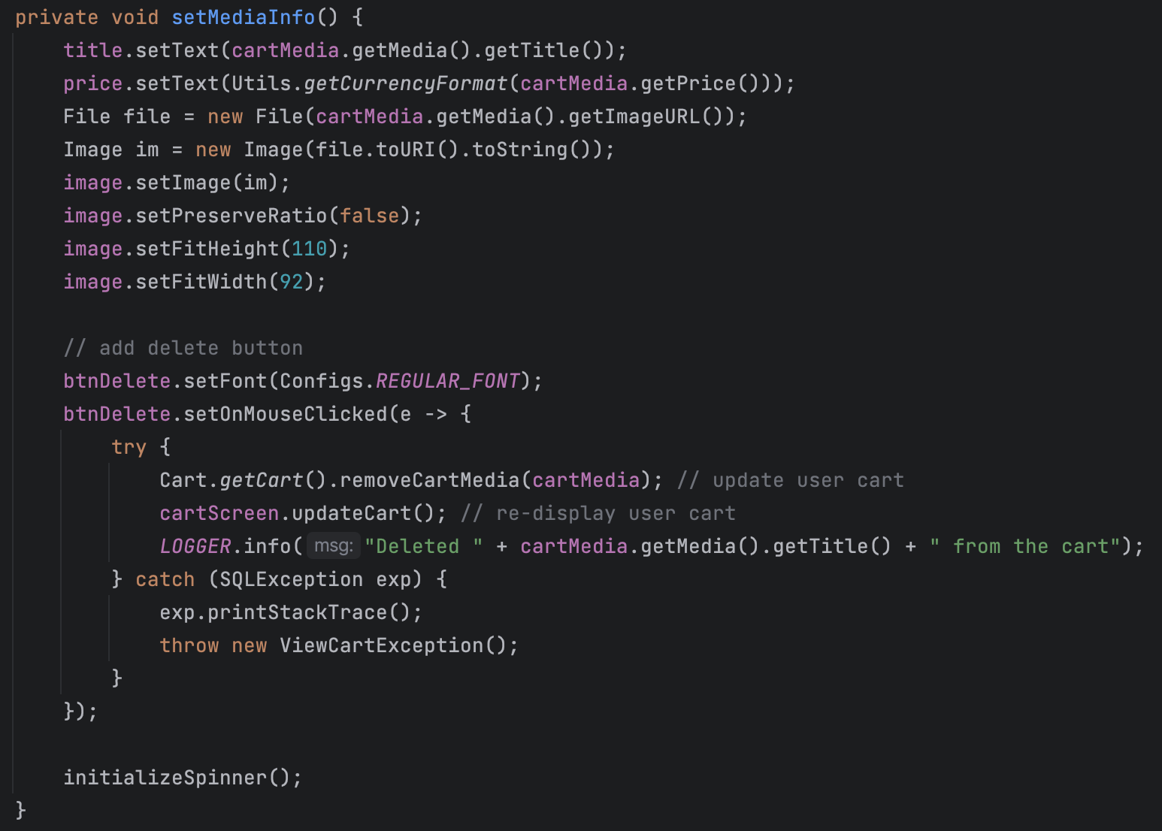

[home.MediaHandler.java](http://home.MediaHandler.java)

